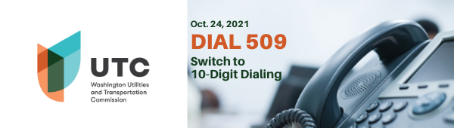
Dear (Insert audience):
On Oct. 24 the switch to 10-digit dialing begins. That means you must include the 509 area code when dialing a local number. In July 2022 seven-digit dialing will no longer work and may cause calls to fail.
Please check to see if yours, your family’s, and friend’s systems are up to date, including:
- life safety systems or medical monitoring devices
- Internet dial-up numbers
- fire or burglar alarm and security systems or gates
- mobile or other wireless phone contact lists
- voicemail services and other similar functions
A business with a 509 telephone number should update all of its materials to include the three-digit area code, such as its:
- company website
- stationary and letterhead
- advertising materials
- contact information
- ID tags and cards
This change to 10-digit dialing in eastern Washington’s 509 area code is a first step toward making sure that everyone in the country will be able to reach the National Suicide Prevention Lifeline using a three-digit code of 988 that launches in 2022.
10-digit dialing will not change:
- Your telephone number or area code
- The price of a call
- Coverage areas.
- Rates and services
- Whether a call is local or long-distance
- Existing three-digit services such as 911, 711, and 211
- The existing 1-800-273-8255 (TALK) suicide prevention hotline number

For more information, please visit our website: www.utc.wa.gov/988 or contact your phone company.

