Issue Brief 1

Climate Trends in Washington State

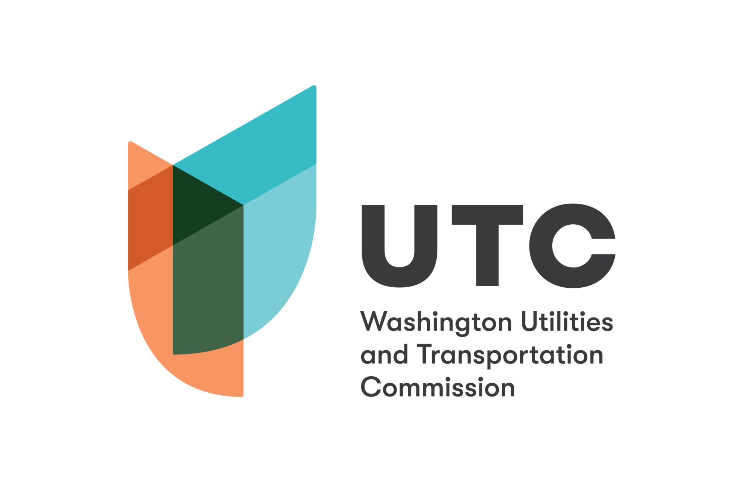

Climate Trends in Washington
The Pacific Northwest has warmed nearly 2° Celsius since 1990, with serious implications for the state’s economy, infrastructure, and public health. For example, in 2021 the region experienced a heat wave with record-high temperatures that led to over 100 deaths. During the same year, massive wildfires affected major economic sectors, damaged roads and power lines, harmed trees, and killed sea life, among other impacts. Later, atmospheric rivers and heavy snow damaged infrastructure and affected the economy.
Warmer winters have reduced mountain snowpack and increased wildfire risk. Warmer coastal waters, rivers, and streams, as well as ocean acidification, pose challenges for the marine ecosystem. As a result of variations in El Niño, Washington is expected to experience prolonged droughts alternating with periods of heavy rainfall. Extreme weather events, including heat waves, wildfires, severe storms, floods, and droughts, are projected to increase in frequency and intensity.

Economic Impacts
Key sectors of Washington’s economy rely on natural resources that will be affected by climate change in the short and long term.
Agriculture: Businesses and people working in the agricultural sector, such as fruit and vegetable farmers, livestock farmers, and foragers, will be affected by reduced availability of water for irrigation, heat stress, floods, and droughts.
Forestry: Increased temperatures and drought conditions are already bringing wildfires, insect infestations, and disease to Washington’s forests. However, climate impacts will vary in the long term. Forests in areas with snowpack will be more vulnerable to droughts; other forests may become more productive as the growing season lengthens and the concentration of carbon dioxide in the air rises.
Fisheries: Commercial fisheries are expected to struggle as fish become less abundant in the face of higher temperatures, warming waters, and ocean acidification. High river temperatures have already killed thousands of migrating salmon in past warm and dry years.
Outdoor recreation: Warmer streams, less snowfall, forest loss, and algal blooms will affect outdoor activities—like skiing, boating, rafting, hunting, fishing, hiking, and backpacking—and the businesses and livelihoods that depend on them.

Infrastructure Impacts
Water, transportation, and energy infrastructure have already been negatively impacted by heavy rainfall, floods, landslides, drought, wildfires and heat waves. Increasingly extreme weather events are expected to decrease the reliability of water, transportation, and energy services, leading to costly damage and closures. Wildfires can cause road and railway closures, force utilities to de-energize transmission lines, and harm water quality. Heavy rains can cause flooding and landslides, which can lead to road and railway closures and reduced water quality. Droughts may decrease water supplies for irrigation, consumption, and electricity generation. Rural and remote areas are and will be the most affected.

Health, Equity, and Cultural Impacts
Climate change is and will continue to negatively affect Washingtonians’ health. Hospital admissions have risen during recent heat waves. Wildfire smoke and smog have also increased respiratory health issues and are expected to increase respiratory illnesses in the long term.
Low-income communities, communities of color are disproportionately affected by climate stressors. Children, the homeless, and the elderly are especially vulnerable to extreme weather events and increased toxin exposure. Farmworkers, who typically earn low wages and face hazards and discrimination in the workplace, are especially vulnerable to heat-related illness.
Tribes are also vulnerable to climate stressors. Washington’s natural spaces and resources, such as salmon, have physical, cultural, and spiritual importance to Northwest Tribes. In addition to facing health challenges, Native American people will struggle to hold onto aspects of their culture as the environment changes.

Sources
- Bush, E. & Burnton, H. “‘Jaw-Dropping’ Forecast Is Warning Sign of Climate Change’s Future Impact in Washington, Scientists Say,” The Seattle Times, June 25, 2021, https://www.seattletimes.com/seattle-news/jaw-dropping-forecast-is-warning-sign-of-climate-changes-future-impact-in-washington-scientists-say/.
- Golden, H. “‘We Have to Adapt’: US Pacific North-West Weighs Plans to Cope with Extreme Weather,” The Guardian, February 3, 2022, https://www.theguardian.com/environment/2022/feb/03/pacific-north-west-extreme-weather-plans.
- U.S. Global Change Research Program, “Fourth National Climate Assessment” (U.S. Global Change Research Program, Washington, DC, 2018), https://nca2018.globalchange.gov.
- Washington State Department of Health. “Heat Wave 2021 | Washington State Department of Health,” accessed March 29, 2022, https://doh.wa.gov/emergencies/be-prepared-be-safe/severe-weather-and-natural-disasters/hot-weather-safety/heat-wave-2021.

