Wedge Diagram
- Dates are on the x-axis and GHG emissions are on the y-axis.
- The top of the chart represents a ‘reference’ scenario, typically an extrapolation of what might happen if no additional policies are implemented.
- Each ‘wedge’ represents a specific policy and the associated emissions reduction year over year.
- The combination of the wedges represents the overall GHG reduction resulting from the combination of policies against the reference scenario.
- The order in which the policies are implemented can influence the size of the wedge. For example, if building retrofits are implemented first, the size of the heat pump can be smaller. This dynamic happens on an annual basis.
- The blue area under the curve represents the remaining emissions; if you sum this up over time, it can be called the carbon liability or carbon budget.
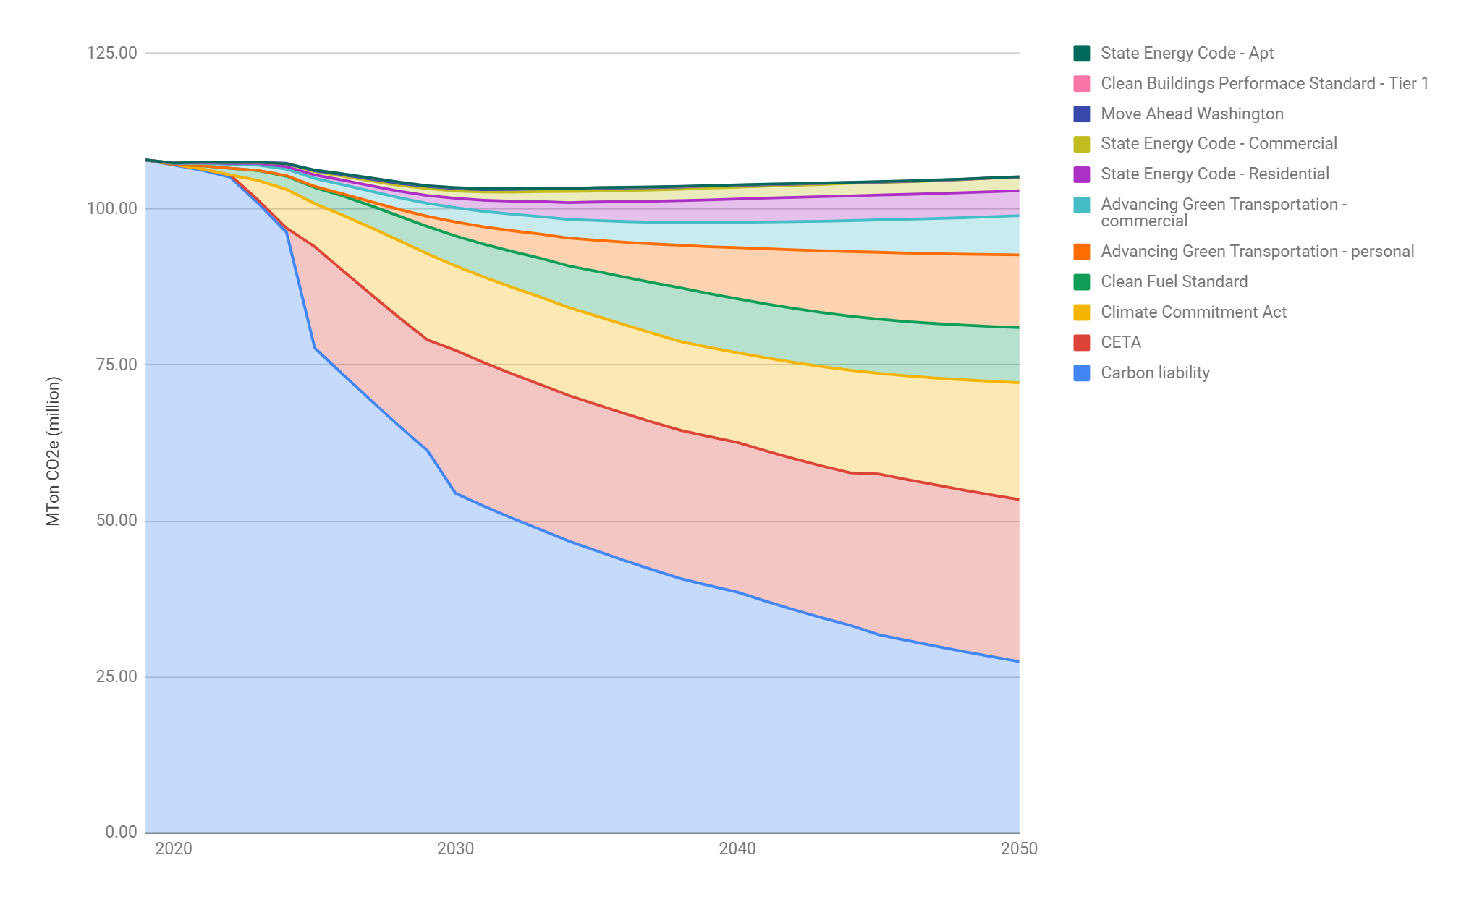

Carbon budgets can sometimes be associated with a target, such as the remaining fair share of the global carbon budget for 1.5 degrees downscaled to Washington State. Carbon budgets can also be analogous to a financial budget, the total amount of carbon one is intended to “expend”.

